Date: 24/06/2025 | IMPROVEMENT TEST | Max. Marks:60
Semester: 6 | UG | Duration: 2 Hour
Course Title: Software Engineering with Agile Technologies |  | Course Code: IS364TA
DEPARTMENTS OF ISE & CSE

Sl.  No. | Questions | M | BT | CO
PART A(QUIZ)
1.1 | List the benefits of Agile Development. | 2 | 2 | 1
1.2 | Give two advantages of Cohesive group. | 2 | 2 | 2
1.3 | Mention the responsibilities of an agile coach. | 2 | 2 | 4
1.4 | For the given scenario identify the personality types:  - The work is a means to an end which is the achievement of individual goals.  - The principal motivation is the presence and actions of  co-workers | 2 | 3 | 3
1.5 | State the principles of Kanban. | 2 | 1 | 4
PART B(TEST)
1a. | Discuss the five principles of Agile methodology. | 5 | 2 | 4
1b. | With a neat diagram explain the extreme programming life cycle. | 5 | 2 | 4
2a. | For a group of students major project being done in a semester course, list the major risks that a typical project will face. | 5 | 3 | 3
2b. | Draw a barchart for the following considering the start date as 1/1/2022  Task Effort(Person- days) Duration(Days) Dependencies  T1 10 10  T2 5 5  T3 9 10 T1(M1)  T4 6 10  T5 8 20 T2,T4(M2) | 5 | 3 | 2
3a. | Taking the example RFID Based Attendance Management system, write the project plan components. | 5 | 3 | 4
3b. | Consider 7 functions with their estimated lines of code. Average productivity based on historical data is 620 LOC/pm and labour rate is Rs. 8000 per mnth. Find the total estimates project cost and effort? F1 – 2340, F2 – 5380, F3 – 6800, F4 –3350, F5 -4950, F6 -2140, F7 – 8400. | 5 | 3 | 4
4a. | Illustrate with an examples following cost optimization techniques:  - Algorithmic cost Modelling  - Expert Judgement | 5 | 2 | 2
4b. | Discuss Maslow’s Hierarchy of Needs. | 5 | 2 | 2
5a. | Discuss the factors influencing Project Management | 6 | 2 | 3
5b. | Classify the following situations in Project, Product, Business Risk:  - Hardware that is essential for the project will not be delivered on schedule  - Experienced staff will leave the project before it is finished.  - The underlying technology on which the system is built is superseded by new technology  - A competitive product is marketed before the system is completed. | 4 | 3 | 3

Scheme and Solution
QUIZ

1.1 | Faster Time to Market, Customer Involvement ,Less documentation  Any two | 1m each
1.2 | Improved Communication and Collaboration  Higher motivation | 1m each
1.3 | Mentoring and Coaching Teams  Facilitating Agile Adoption  Promoting Continuous Improvement  Any two from above | 1m each
1.4 | - The work is a means to an end which is the achievement of individual goals.-goal oriented people  - The principal motivation is the presence and actions of  co-workers-Interaction oriented | 1m each
1.5 | Start with What You Do Now  Agree to Pursue Incremental, Evolutionary Change  Respect the Current Process, Roles, and Responsibilities  Encourage Acts of Leadership at All Levels  Any two from above | 1m each
 | PART-B
1a | Customer Satisfaction Through Early and Continuous Delivery  Embrace Change,  Deliver Working Software Frequently  fostering collaboration between business and development teams  Motivated Individuals | 1m each
1b | Diagram-2m  Explanation-3m
2a | underestimating the time needed to complete tasks.  Miscommunication or unclear roles and responsibilities.  lack of collaboration among team members.  continuous additions to the project requirements.  Attempting to include too many features beyond what can be completed in the given time.  Choosing tools or technologies that are too complex or unfamiliar.  Bugs, integration issues, or technical roadblocks that delay progress  Any 5 from above points | 1m each
2b | 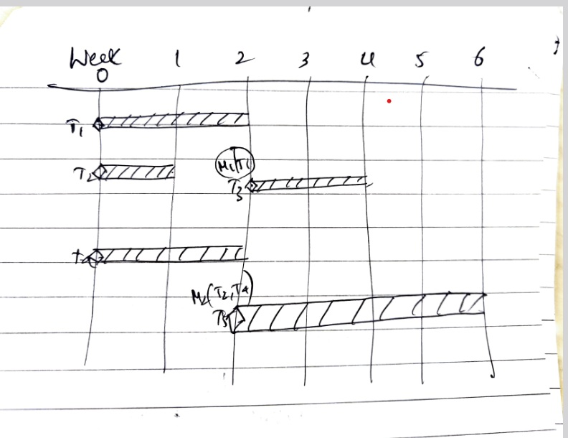
3a | Introduction  Project organization  Risk analysis  Hardware and software resource requirements  Work breakdown  Project schedule  Monitoring and reporting mechanisms  Any 5 components from above
3b | We are given LOC for 7 functions:  - F1 = 2340  - F2 = 5380  - F3 = 6800  - F4 = 3350  - F5 = 4950  - F6 = 2140  - F7 = 8400  Total LOC = 2340 + 5380 + 6800 + 3350 + 4950 + 2140 + 8400 = 33,360 LOC  Calculating Effort (Person-Months)  Using the average productivity = 620 LOC/person-month:  Effort=Total LOC/Productivity=33360/620≈53.81 person-months  Calculating Cost  Using the labour rate = Rs. 8000 per person-month:  Cost=Effort×Labour Rate=53.81×8000=Rs.430,480
4a | - Algorithmic cost Modelling—2.5m  - Expert Judgement—2.5m
4b |  | 1m each
5a | - Company size  - Software customers  - Software size  - Software type  - Organizational culture  - Software development processes  Any five factors from above | 1m each
5b | - Hardware that is essential for the project will not be delivered on schedule-project  - Experienced staff will leave the project before it is finished.-Project  - The underlying technology on which the system is built is superseded by new technology.-Business  - A competitive product is marketed before the system is completed.-Business

